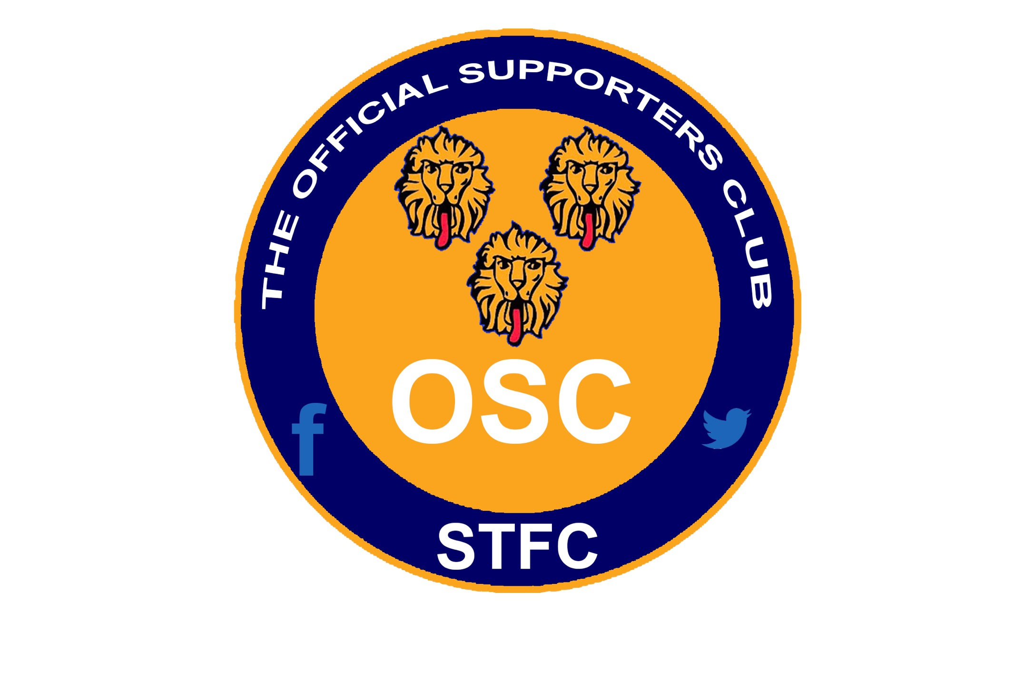
Shrewsbury Town FC Official Supporters Club
A.G.M. Meeting held on Wednesday 3rd July 2019
at the Wild Pig and Restaurant - Shrewsbury

Agenda

Present:

Apologies:

Matters arising from the 2018/19 meeting:

Chairman’s Report

- OSC committee standing down

- Election of New OSC Travel Group
- Martyn Hall - Chair
- Brian Jones – Travel Co-Ordinator
- Simon Moore – Finance
- Rob Lewis – Website & Social Media

New OSC Travel Coach Stewards
- Mike Ashton
- Terry Feltus
- Nigel Oakley
- Trevor Shepherd
- Richard Thomas
- Any supporters in attendance who wish to help?

- New OSC Travel Group
- Book & Pay system through Owen’s Travelmaster will remain in effect.
- One collection point from Shrewsbury at the Montgomery Waters Meadow.
- New OSC organizational format with no monthly meetings for committee members, only holding meetings when required (One season trail).
- New coach steward responsibilities including: check supporters on the coach at the relevant pick-up points & counting supporters when they return to the coach after each match. No drinks service will be offered onboard the coach, nor a raffle.
- New OSC rules to replace current constitution to be drafted.
- 2019/20 OSC Travel Club pricing and departure times.

- OSC financial accounts (unaudited).

A.O.B.

